145 THOMAS JAMES EDWIN LINDSAY

Thomas was born at Harris Park, NSW, on 12th March 1890, the son of William Lindsay and his wife Mary Ann, nee Taylor. He was a Clerk with he railways and a Captain in the senior Cadets. In 1913 he married Margaret Batey with whom he had two children.
He enlisted in A Company. AN&MEF on 11th August 1914 and was promoted sergeant on 18th August. He returned from Rabaul and was discharged on 4th March 1915 having completed 206 days service.
On 1st April he enlisted in d company, 20th battalion and on 21st May was promoted sergeant. He departed Sydney on the BERRIMA on 26th June and landed at Gallipoli on 22nd August. He contracted enteric fever and was evacuated on 25th October, first to Malta and then to England. He Left England for Australia on 21st Jan 1916 aboard the COMMONWEALTH.
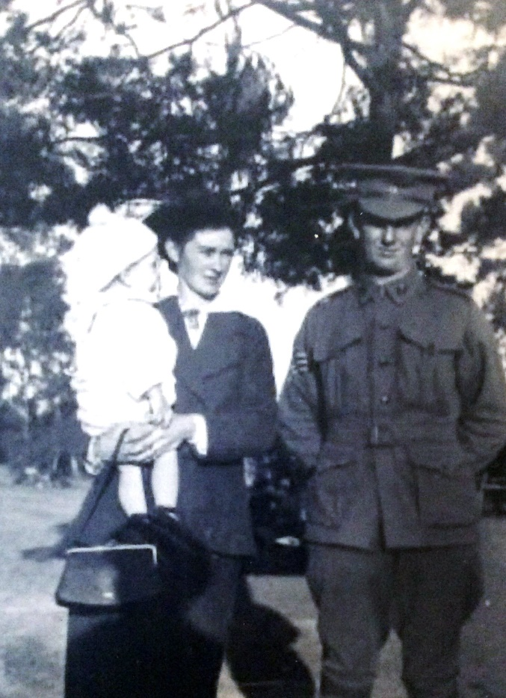
After recovering he received a commission as a 2nd Lt in the 45th Battalion and sailed with the 8th Reinforcements on 26th November 1916 aboard the BELTANA, arriving in Davenport on 21st Jan 1917.
On 16th July 1917, James was killed in action and is buried at the Millecourt Communal Cemetery, near Albert and is remembered on Panel 140 at the Australian War memorial, Canberra

