856 JOHN MAHER LYONS

John was born at Emmaville in the New England District on 2nd August 1887, the son of Patrick Lyons and Cecelia Mary, nee Connelly.
On his enlistment in the AN&MEF on 11th August 1914, he stated he was single, a tram conductor and that his next of kin was his sister, Madge Lyons, “Lyonsville”, Middle St, South Kensington.
John returned to Australia and was discharged, tern expired, on 18th Jan 1915 having served 161 days in the AN&MEF.
On return he married Evelyn Magdalene Bennett and enlisted in the 17th Battalion, AIF on 1st Feb 1915. He was promoted Corporal on 29th March 1915 and departed Sydney for the Middle East on 12th May 1915 aboard the THEMISTOCLES.
On 13th August 1915, whilst in Egypt he was promoted Lance Sergeant before the Battalion moved onto the Gallipoli Peninsular, landing there on 20th August 1915. Shortly afterwards, on 14th September 1915, John was promoted to Sergeant and remained on the peninsular until the Battalion was evacuated in December of the same year.
The Battalion moved to France in March 1916 and on 26th July 1916 he received a gunshot wound to the foot whilst at Poziers. He was awarded the Military Medal for “…general meritorious service with (his) battalion and gallantry in action” at Gallipoli and Poziers”.
On 13th September he was recommended for, and received, the Meritorious Service Medal “For general good work and devotion to duty. Has been with the Battalion since its inception. A most efficient member, and did very good work as BOIS GRENIER, particularly in the 5th Bde raid during 26/27th June. Also at Poziers during the Bombing Fight at MUNSTER ALLEY, where he was wounded while bravely leading his men.”
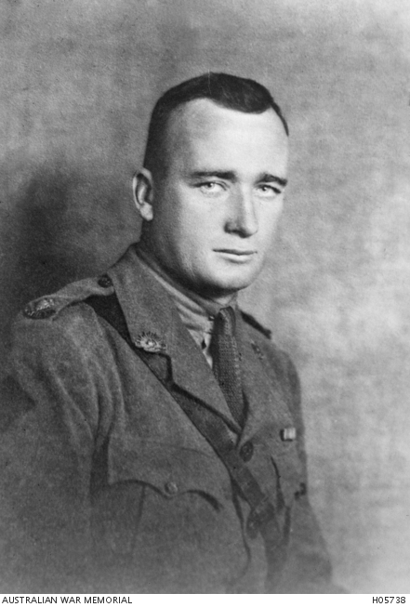
On 1st January 1917, John was promoted 2nd Lieutenant and on 9th October 1917 was killed in action. A report of his death was given by Lt Col Travers, as follows;
“Lyons was a Lieut in 17th Battalion but had been with me in German New Guinea and also in a raid with me in the 17th Battalion made by the 5th Brigade in June 1916. He was a very excellent soldier; his name was Jack I think he came from the New England district. I last saw him in Wandsworth Hospital when wounded in the foot about April 1917. He rejoined the battalion was wounded in the attack on 9/10/17 at Passchendaele when the 17th Battalion were taking the final objective: the flank attack Battalions failed to take their objectives and the 17th Battalion were forced to fall back. Lyons I understand had been mortally wounded before they fell back and was placed in a pill box and the stretched bearer had not time to evacuate him as they fell back when the pill box was recaptured, it was found he had died of wounds and was found there. This information was given by Major Basil Holmes D.S.O. and the Colonel now Brig-General Martin C.M.G. D.S.O. The above report is from my memory of conversation I had with Major Holmes and Colonel Martin and may not be absolutely correct. Lyons had a D.C.M, a Meritorious Service Medal and I think a Military Cross and he was a grand fighter. He had been a Sergeant in B Company of 17th Battalion and was one of the men specially selected for the raid in June 1916, the first raid made by the 5th Brigade in France”
After his death he was awarded the Military Cross for “…Conspicuous gallantry and courage during operations on 9th Oct on PASSCHENDAELE RIDGE. He did splendid work in getting the men on the jumping off tape in the face of a heavy enemy barrage and despite darkness mud and other serious weather obstacles, got the men into their allotted positions with very few casualties. During the trying wait for zero, he kept walking about freely among the men, encouraging them and seeing that all was correct. He led forward the first wave, and when all his platoon had become casualties, he collected spare men from another Brigade and organised them along a flank which had been left exposed. He then collected more men and got them consolidating a gap in the front line. He led about 15 men up to the slope against ASSYRIA HOUSE. He captured 14 prisoners and 6 machine guns. It was entirely due to his leadership and coolness that the men got so far forward. He was severely wounded. He holds the Military Medal and Meritorious Service Medal, both gained in this war.”
John Lyons has no known grave and is remembered on the Menin Gate and on Panel 83 at the Australian War Memorial, Canberra.

