152 SAMUEL STANLEY MARTIN

Samual was born at New Lambton, Newcastle, NSW in 1892, the son of Samuel and Mary Martin. His father died in 1900 when Samuel was just 8 years old.
He enlisted in A Company, AN&MEF stating that he was a Loco Fireman with NSW Railways and single, giving his mother at Coby Rd, New Lambton as his next of kin. He returned fro Rabaul and was discharged on 4th March 1915 having completed 206 days service.
On 22nd July 1915 he enlisted in the AIF as part of the 11th Reinforcements, 3rd Battalion, regimental number 3376. He left Sydney aboard the EURIPIDES on 2nd November 1915 and was hospitalised with influenza shortly after arriving in Egypt. He moved to France in March 1916 and was wounded on 18th August 1916. He was evacuated to England and admitted to the 3rd West General Hospital from where he was discharged on 11th October.
Sometime in 1918 he married Maud Wilton at Warminster, Wiltshire with who he already had a daughter. He rejoined his unit in France on 1st October 1918.
He returned home on the PORT NAPIER, arriving in Sydney on 10th Feb 19120 and was discharged from the AIF on 12th May 1920. He continued his employment with the NSW Railways after the war
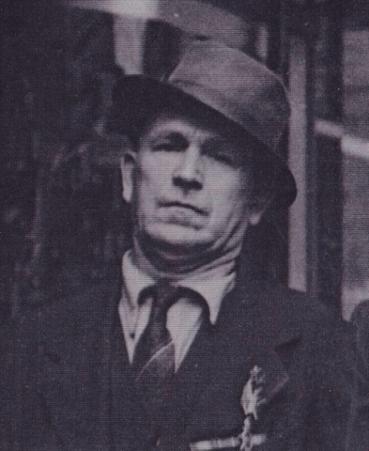

Samuel died at Ryde, NSW on 24th Jan 1957.

