1034 FREDERICK MCGLASHAN

Frederick was born in Newcastle, the son of Frederick William McGlashan and his wife Ada, nee Hendry. He enlisted in D Company, AN&MEF stating that he was a Commercial Traveller and single, giving his mother at Vaughan St, Lidcombe as his next of kin. He returned from Rabaul and was discharged on 4th March 1915 having completed 206 days service.
On 3rd March he joined the AIF and allocated to D Company, 18th Battalion, regimental number 1359. He left Sydney aboard the THEMISTOCLES on 12th May, arriving in Suez on 12th June.
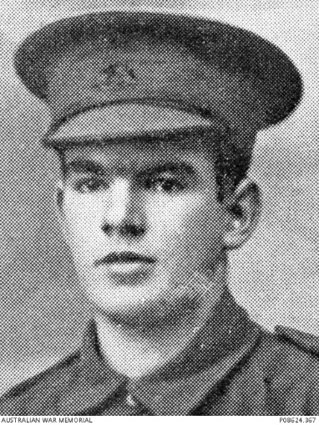

On the day they arrive on Gallipoli, 22nd August, he was listed as missing. In an interview given in Jan 1916 one of his fellow soldiers, Pte William Charles Brown regimental number 1142, describe what happened as follows: =
“He was in my Co and we called him Fred. He was killed in the first charge we made on Chocolate Hill when we were enfiladed on both sides. I passed him lying wounded with a bullet in the stomach. We passed him later, and he had been shot several times again. We were unable to recover any of the bodies. I heard the Gurkhas had buried 180 of our chaps but did not take their discs. We lost 650 in that charge. He asked us to take his water bottle away.”
At a Court of Enquiry held in Egypt on 26th Jan 1916 it was concluded that it was “reasonable to suppose he died’ on 22nd August 1915.
Fred is remembered at the Lone Pine Memorial, Gallipoli and on Panel 86 at the Australian War Memorial, Canberra.

