1058 THOMAS WILLIAM HOWARD

Thomas Howard was born at McDonaldtown, Sydney. On his Attestation Papers he described himself as being 28 years old, single, a labourer and his mother, Annie Howard of Raglan St, Long Bay, was listed as his next of kin.
Thomas enlisted on 11th August 1914, was assigned to E Company and served until 28th January 1915, a total of 171 days. He was discharged “termination of period of engagement”.
Sometime between this period of service and his next period of service he married Elsie May Bushley of Randwick, who he subsequently nominated as his next of kin.
On 17th May 1915, Thomas enlisted in the AIF (#6721) and was assigned to the 8th Field Ambulance here he served as a stretcher bearer. On 10th November 1915 he left Australia aboard the ASCANIUS for the Middle East where he served until his unit left for France on 17th June 1916 aboard the TRANSYLVANIA.
On the evening/morning of 19th/20th July 1916, the 8th Field Ambulance was stationed at Fort Rompu, in France, close to the Belgian border. Thomas was awarded a Military Medal for working “…continuously in bringing cases in from the Regimental aid posts. He went out in daylight with Stretcher Bears from 56th Battalion and succeeded in bringing in 5 wounded men from “NO MAN’S LAND” under rifle and machine gun fire, Private Howard also did excellent work between the period 16th and 19th July 1916.”
In May 1917, Thomas Howard was a warded a Bar to his Military Medal. In his Diary for the 14th and 15th May 1917, the Commanding Officer of the 8th Field Ambulance, Colonel A. E. Shepherd, noted there was a very heavy barrage of gas shells and High Explosives in and around where they were based at Noreuil, France. He went on “…Maj Bond (8FAMB) and Captain Minty (15th FAMB) especially distinguished themselves by their coolness and thus stimulated all ranks to continue their activities to the wounded and gas cases, at a critical time when the slightest error might have had serious effects. The conduct of the whole of the AAMC is to be highly commended”
Major Lionel Wilfred Bond was awarded the Distinguished Service Order and Captain Cyril Charles Minty was awarded the Military Cross. Four other ranks, L/Cpl Arthur John Moore, Pte William Robert Bowden, Pte Alfred Douglas Maggs and Pte Thomas William Howard, all of the 8th Field Ambulance were awarded Military Medals. The citation read “On the night of 14th/15th May, during an incessant storm of H.E. and gas shells in the vicinity of Noreuil, these men, acting under the initiative their N.C.O., proceeded to the rescue of two wounded men who were lying on the road. Despite the heavy shelling, they succeeded in adjusting the gas masks and dressing the wounds of the patients. They then carried the patients through the barrage to a place of safety. Their gallant conduct undoubtedly saved the patients from gas poisoning or death from wounds.”

On 4th September 1918 Thomas returned to Sydney aboard the ‘Kanowna” and was discharged on 27 March 1919 as medically unfit due to “Trench Fever”.

On 8th August 1919 Thomas again enlisted (#86810), this time in the Special Service Unit, a Unit established to provide an escort for returning “enemy deportees”. There were ten ships involved in the exercise with Thomas aboard the HMAT RIO NEGRO which left Sydney on 19th August 1919, arriving in London on 27th October 1917. There were 6 Officers, 6 Warrant Officers and Sergeants and 55 Other Ranks in the Unit.
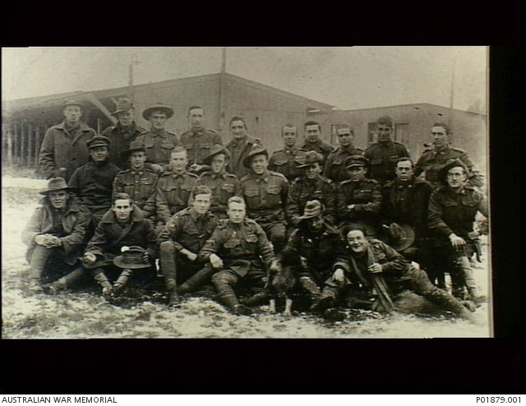
(Group shot of some of the members of the Special Service Unit who were aboard the Rio Negro on its trip from Australia to Europe in 1919).
On 22nd November 1919 Thomas returned to Australia aboard the AENEAS and was discharged for the final time on 26th January 1920.

