CAPT FREDERICK ARTHUR MAGUIRE

Frederick was born at Cobar on 28th March 1888, the son of George Frederick Maguire and his wife Martha, nee Smith. He completed his medical degree at Sydney University and on 6th December 1913, he married Alma Myee Dive.
He joined the AMC, AN&MEF as a Captain and was promoted Major on 12th Oct 1914, as PMO in Rabaul. He returned to Sydney and his appointment was terminated on 4th March 1915.
On 23rd Feb he was appointed Major with the 8th Field Ambulance and on 12th Feb 1916 was promoted Lt-Col, commanding the 9th Field Ambulance. He left Sydney aboard the ARGYLLSHIRE on 11th May 1916, arriving in Liverpool on 10th July 1916. He moved to France on 23rd Nov 1916.
Frederick was promoted Colonel, received the Distinguished Service Order (DSO) and was Mentioned in Dispatches (MID) on four separate occasions and returned from England aboard the MANYUA on 2rd Jan 1920 and had his appointment to the AIF terminated on 12th April 1920.
Alma died and on 2nd September 1922 he married Alma’s sister, Beatrice. He was appointed temporary Major-General, Director General of Medical Services from 27th March 1941 till 5th April 1942.
In 1950 Beatrice died and on 17th December 1951 he married fellow doctor Mary Mabel McElhone.
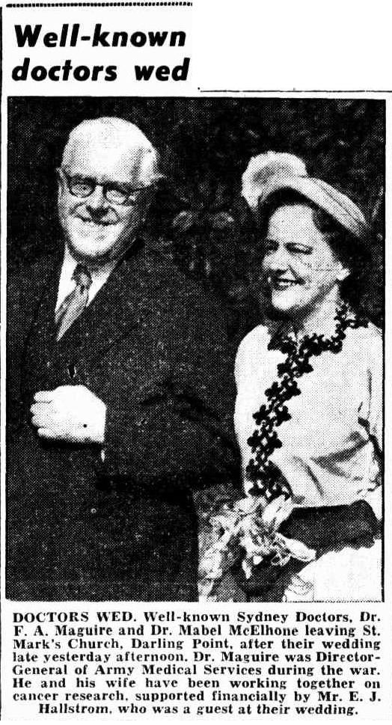
Frederick died at Woollahra on 10 June 1953 age 75.

