LT JOHN MALBON MAUGHAN

John was born at Ashfield, NSW, on 19th December 1877, the son of John Maughan and his wife Bertha Windeyer, nee Thompson. He attained a BA from Oxford and was a practising solicitor. He was appointed a lieutenant in F Company, AN&MEF and for a period from 2nd to 24th December 1914, he was Officer Commanding the Garrison at Kieta, Bougainville.
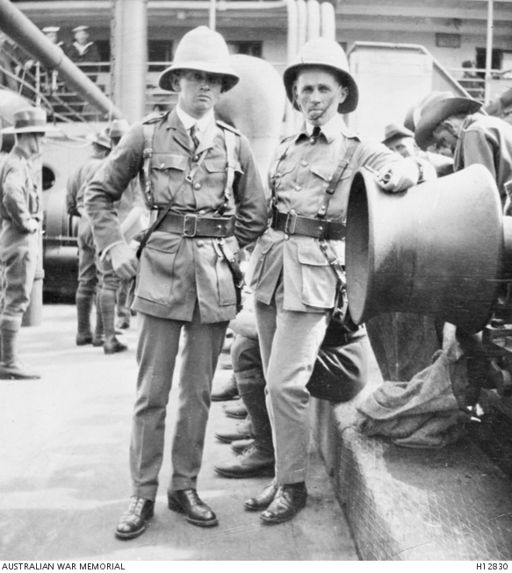
On right aboard BERRIMA 1914

On return from Rabaul he accepted a commission in the 17th Battalion and sailed with the battalion, leaving Sydney on 12th May 1915 aboard the THEMISTOCLES. He landed at Gallipoli on 20th August 1915 and appointed temporary Major on 6th December, which was made substantive on 9th June 1916, after the battalion had moved to France.
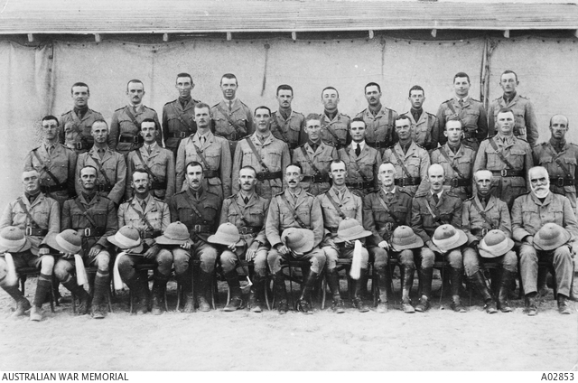
Officers of the 17th in Egypt 1915. John, front row, 2nd from right.

On 16th July 1916 he was wounded in the head at Pozieres and his actions on that day earned him a Distinguished Service Order (DSO) – “for conspicuous gallantry during a bomb fight. He stood before the parapet firing a ‘Very” pistol to light the grounds for his bombers. He was exposed to many snipers’ fire from ‘No Man’s Land” and the continual firing of his pistol showed his position. Finally he was wounded.”
He rejoined his battalion on 1st September 1916 and transferred to the 20th Battalion on 10th Jan 1917. He left England on 11th Jan 1918 aboard the PORT Darwin and his appointment to the AIF was terminated on 21st March 1918.
He returned to his life as a solicitor and was Commissioned for Scouts in NSW for 15 years from around 1931.
John died on 14th September 1950 aged 72.

