LT JOHN AMBROSE MCDOWELL

John was born at Glebe, NSW, on 9th July 1888, the son of Alexander McDowell and his wife Fanny, nee Storey. He joined the department of Local Government in early 1910 and on 6th July the same year he married Nadia Beatrice Butters at St Hilda’s Church, Katoomba stating that he was a Deputy Town Clerk. On 1 July 1913 he transferred to the Department of Public Works as a clerk.
He enlisted in D Company, AN&MEF were he received his commission as a 2nd Lt. He was promoted lieutenant in January 1915 and returned from Rabaul and was discharged on 4th March 1915 having completed 206 days service.
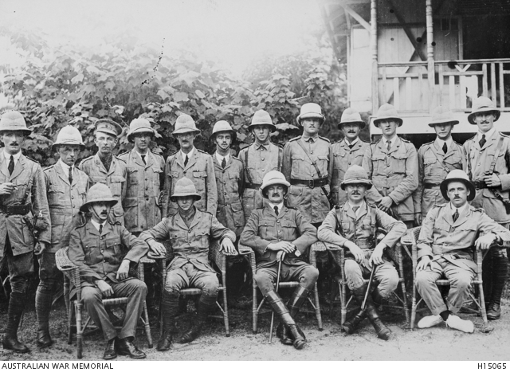
In Rabaul. John 8th from left. Back row
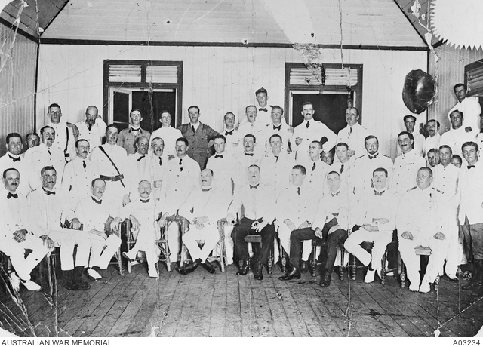
In the Officer’s Mess, Rabaul. John 4th from left, middle row
On 7th May 1915 he was appointed Captain in the 18th Battalion, AIF, and sailed for the middle East on 25th June 1915 aboard the CERAMIC. He arrived at Gallipoli on 16th August and was evacuated to Mudros on 23rd September with shellshock. From there he was evacuated to the UK where he boarded the STAR IF INDIA on 12th December 1915 for return to Australia.
After a period of recovery he boarded the HORORATA on 2nd May 1916 for England where he went to France, rejoining his battalion on 21st November
On 13th May 1917 he was promoted Major with the 34th Battalion and transferred to the 36th Battalion on 6th November and spent a period acting as the battalion’s Commanding Officer.
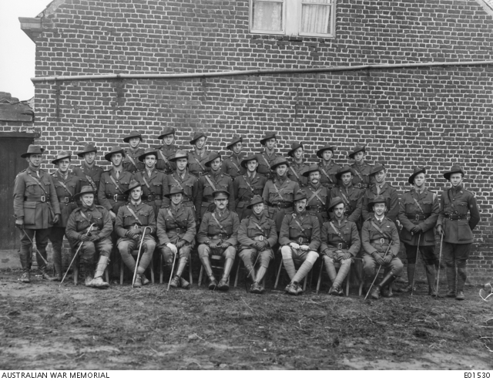
Officers of the 36th Battalion, France 24th Jan 1918. 4th from left, front row.

On the Somme, he received a gunshot wound to the arm and leg on 13th April 1918 and evacuated to England from here he departed an 25th June 1918 aboard the KAROOLA. His appointment to the AIF was terminated on 7th April 1918.
John died at Randwick on 4th February 1932, aged 44.

