513 CHARLES PATRICK JOSEPH LARSEN

Charles was born in West Melbourne on 31st Jan 1894, the son of Henrick (Henry) Larsen and his wife Mary Jane, nee Kennedy. Henrick died when Charles was just 2 years old and his mother married William Herbert Macbeth some 4 years later. Charles enlisted in E Company AN&MEF stating he was a farmer and single, giving his mother at 15 Kepos St Redfern as his next of kin. He left Rabaul on 9th Jan 1915 aboard the EASTERN and was discharged on 18th Jan 1915 having completed 161 days service.
On 16th Feb 1915 he joined the 17th Battalion, regimental number 770. On 12th May 1915 he left Sydney aboard the THEMISTOCLES as an acting sergeant in B Company. He never made it to Gallipoli, being admitted to hospital on 20th June with appendiceal adhesions. On discharge from hospital, he was returned to Australia aboard the HORORATA, leaving Suez on 25th August.
Charles resumed duties on 11th Jan 1916 had was allocated to the 10th Reinforcements, 17th Battalion and left Sydney on 9th September aboard the EURIPIDES, rejoining his battalion in France on 18th December. On 17th November 1917 he was sentenced to 7 Days field punishment for trying to pass off a 10 shilling note as a one pound note.
In Jan 1918 he was wounded in the right knee, the wound turning septic. On 13th March 1918 he left England on the DUNVEGAN CASTLE, transferred to the TOFUA at Capetown, arriving back in Melbourne on 14th June. He was subsequently discharged, medically unfit on1th August 1918.
On 18th June 1919 he again enlisted in the AN&MEF, regimental number 1907 and sailed for Rabaul on 15th July aboard the MELUSIA. He was taken on Garrison Strength on 29th July and moved to Kokopo with the Harbour Mater’s Office on 20th September. He returned to Australia on the MELUSIUA on 30th September and was again discharged, medically unfit, on 10th Feb 1920.
On 19th Feb 1922 he married Ethel Hilda Mileski and on 9th feb 1942 he enlisted again, service number Q124789, this time as a WO2 with the Volunteer Defence Group where he remained until his discharge on 18th Feb 1944.
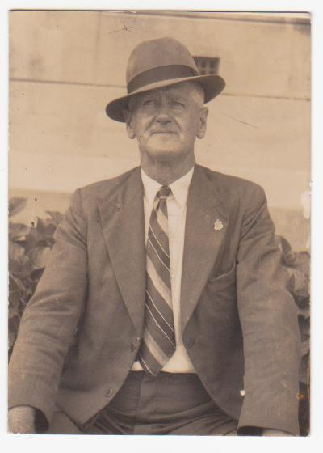
Charles died in Queensland on 22nd October 1969 aged 75.

