4 LEONARD JAMES MOBBS

Leonard was born on 2nd October 1898 at Rydalmere, NSW, the son of James Albert and Winifred Ann Mobbs.
Leonard enlisted into the Army Medical Corps component of the AN&MEF on 13th August 1914, direct from the Regular Army where he was a Military Staff Clerk in the Medical Corps, having served in the Army since 17th Feb 1909. On his attestation papers he stated he was a soldier by occupation and was married. He nominated his wife, Elizabeth Mobbs, nee McGregor, c/- his father at Narara, NSW as his next of kin.
He was appointed Sergeant Clerk on 18th August 1914 and returned to Australia and was discharged on 4th March 1915, time expired having served 205 days.

On 10th February 1916 the 9th Field Ambulance was raised and commenced recruiting at its Liverpool Base. On 17th March 1916, Leonard was taken on strength as a Warrant Office Class 1, service number 11876.
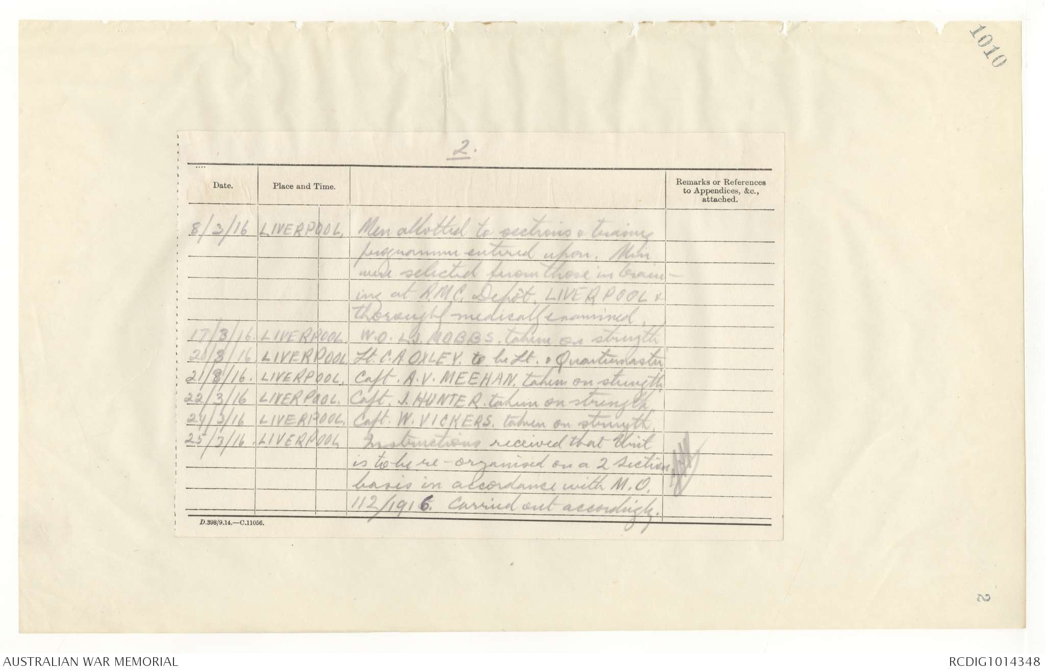
9th Australian Field Ambulance Unit Diary.

On 11th May 1916 the unit embarked aboard the ARGYLLSHIRE, arriving in Plymouth on 10th July 1916. After training in England Leonard moved to France in February 1917.

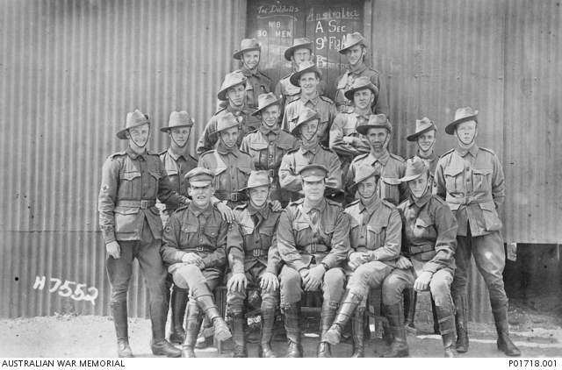

Stretcher Bearers of the 9th Field Ambulance at Larkhill, shortly after their arrival in England in 1916. WO Mobbs if in the centre, front row.

In March 1918, Leonard was awarded the Meritorious Service Medal – “For good work and devotion to duty while serving with his unit in the Field. This Warrant Officer has been most thorough in all his work and has at all times displayed the utmost zeal in carrying out his duties. During the Battle of MESSINES, he was Warrant Officer in charge of personnel at the Corps Main Dressing Station at PONT d’ACHELLES. He handled his large and varied staff with skill and judgement and contributed in a large measure to the rapid and successful evacuation of large numbers of wounded. During the Battle of YPRES on 4th and 12th October 1917, he was in charge of the organisation of bearer parties and reliefs having over 600 bearers constantly coming and going. Mr. Mobbs worked indefatigably and was always in closest touch with his work and seeing to the welfare and comfort of the men. This Warrant Officer served with the Australian Naval and Military Expedition to GERMAN NEW GUINEA in 1914-1915.”
On 8th December 1918, Leonard was transferred to the 2nd Australian Garrison Hospital as Quartermaster and was made a Honorary Lieutenant.
Leonard departed England aboard the ORITA on 23rd June 1918 at which time his appointment as Hon Lt ceased.

Leonard continued in the Medical Corps after returning to Australia eventually, on 19th July 1923 being transferred to the Reserve of Officers as a Lieutenant. Between the wars he worked in the Commonwealth Public Service, Department of Defence.

At the outbreak of World War 2, Leonard was called up from the Reserve and served as Captain, and T/Maj in the Ordnance Depot, 2nd Military District, Eastern Command, service number NX8779. He was in service when he died at home at Randwick on 20th November 1941 of Hypertensive Heart Disease.
Leonard is buried at the Eastern Suburbs Memorial Park and is remembered on Panel 90 at the Australian War Memorial, Canberra.
Leonard’s son, James William Mobbs also served in the Army in World War 2, service number NX8779.

