352 FRANCIS ALMUND WEARNE HOCKING

Francis was born at Petersham, NSW, the son of Francis Joseph Hocking and his wife, Jane Susannah, nee Wearne.
He enlisted in the AN&MEF and was posted to C Company. He stated that he was a commercial traveller and single, Giving his father at “Camira”, Victoria St, Lewisham as his next of kin. He returned from Rabaul and was discharged on 4th March 1915, having completed 206 days service.
On 1st July 1915 he enlisted in the AIF and was posted to 8th Reinforcements, 3rd Battalion. He left Sydney on 9th August 1915 aboard the RUNIC and joined the 5th Training Battalion at Heliopolis on 19th September. He was taken on strength by the 3rd Battalion on Gallipoli on 20th Oct and was promoted corporal on 3rd December. He arrived back at Alexandria aboard the HMT SILMA on 29th December and transferred to the 55th Battalion on 13th Feb 1916.
He was promoted sergeant on 31st May and arrived in Marseilles on 29th June. He was awarded the Distinguished Conduct Medal on 28th September 1916 for – “... conspicuous gallantry during operations. He organised carrying parties to supply machine guns with ammunition – these guns covered the retreat of the troops to the Communication Trench – Sgt Hocking also dressed the wounds of a man in the open and got him to safety.”

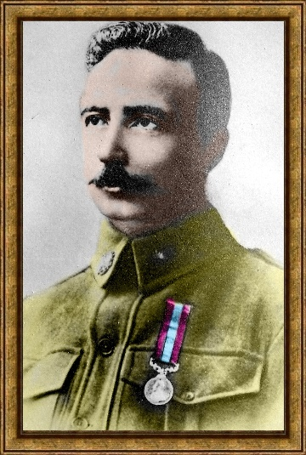
Francis with his DCM
He was wounded on 2nd Feb 1917 and died of these wounds two days later at a Casualty Clearing Station. He is buried at the Dernancourt Communal Cemetery and is remembered at Panel 160 at the Australian War Memorial, Canberra.

