147 LIONEL OSCAR MCRAE

Lionel was born on 20th March 1889 at Carlton, Victoria, the son of Lionel and Annie McCrae. On 11th August 1914 he joined the AN&MEF and was assigned to A Company. He listed his occupation as “Labourer on Railway” and gave his mother as his next of kin, his father having died.
Lionel competed his period of service on 4th March 1915, having served 206 days in the AN&MEF.
Eight days later, on 12th March 1915 he joined the Ammunition Reserve, 4th Light Horse Brigade (service number 19) as driver and left for the Middle East on 22nd June 1915 aboard the VESTALIA.
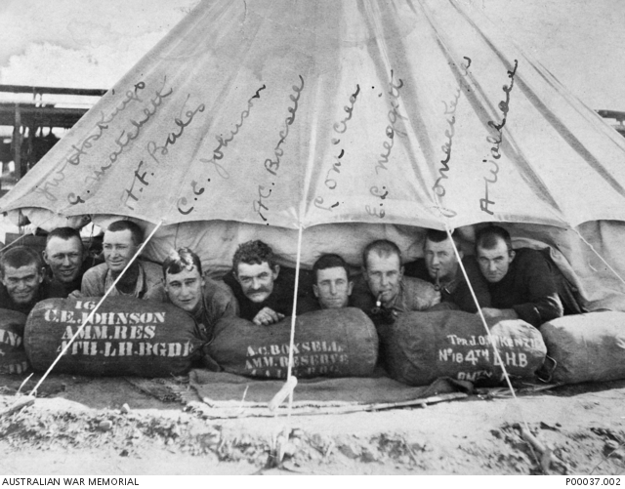
Members of the Ammunition Reserve, 4th Light Horse, Cairo, Egypt November 1915
In March 1916 he moved to France and on 19th September 1916 he transferred to the 18th Battalion as a driver and was given a new service number, 8929.
On 3rd June 1917, the CO, 18th Battalion announced that 4 Military Crosses, on Distinguished Conduct Medal and 9 Military Medals, had been awarded for operations on 3/5th May 1917.
The recommendation for Privates McCrae, Skelton and Jackson, all runners for the Battalion stated that:
“These men besides carrying messages, each made several journeys up to the enemy’s wire, endeavouring to locate points where our troops had entered. The information that they brought back was of considerable value when the situation was still obscure. Pte MACRAE at night guided a party of stretcher bearers out to the enemy’s wire. The part brought in 50 wounded. (3rd May near HOREUIL)

At that time the Battalion was involved in the second Battle of Bullecourt which was described by historian Charles Bean as follows:
'The Second Bullecourt (battle) was, in some ways, the stoutest achievement of the Australian soldier in France'
On 20th September 1917, the 18th Battalion was located near Zonnebeke close to Polygon Woods when Lionel was killed in action. Two accounts of his death are recorded, the first by Private C A Hughes, who states:
“About 20th Sept near Anzac House, near Westhoek Ridge, on right of Zonnebeke. About 300 yards behind the lines, McCrae was following up Lieut. Cl G. Murphy, Colonel of Battn. Germans were throwing over shells. When the Colonel turned round to look for McCrae he had disappeared. About 3rd Oct, I and others searched the ground for best part of the day but could find no trace of his body.
Was a general favourite and was following up the Colonel in case latter wanted to send a message back.”
The second account was from Pte C Blyton, who stated:
“H.Q, runner. At. Polygon Wood. He was with Colonel well behind lines, coming up to the lines. Shell fell behind him, almost direct hit, nothing more was seen of him. I was wounded earlier in the day and had been taken out, was told above by one of his mates, Pte Arthur Jackson, No. 18th Battn. HQ runner. Col was blown into the air but not wounded. Came from Balmain, N.S.W.”
His name is inscribed on the Menin Gate and on Panel 86 at the Australian War Memorial, Canberra.

