561 HAROLD WOODFORD JOHNSON

Harold was born at Black Springs, NSW on 14th Dec 1892, the son of George Johnson and his wife Agnes (Annie), nee Murray. At enlistment Harold was a second lieutenant in E Company 18th Infantry CMF Unit.
On 11th August 1914 he enlisted in G Company, AN&MEF, stating that he was an auditor/accountant and single, giving his mother at “Woodford”, West St, North Sydney as his next of kin. On the day before departure he was promoted to col;our sergeant and then appointed 2Lt on 20th November 1914. He returned from Rabaul and was discharged on 4th March having completed 206 days service.
On 5th May 1915 he was given a commission with the 17th Battalion and left Sydney with the battalion on 12th May 1915 aboard the THEMISTOCLES. He landed on Gallipoli on 20th August and was promoted Captain on 3rd Nov whilst on Gallipoli.
The battalion moved to France where, on 3rd June 1917 he was awarded the Military Cross(MC) for; -
“… general good work and devotion to duty. Adjutant during the whole time the battalion has been in France – 24th March to the present date {21st September 1916}. His work has been most thorough and efficient and has materially assisted in raising the Bn to a state of efficiency to which he now attains. The whole of the Orderly room work has been under his supervision and has been carried out in a most efficient manner.”
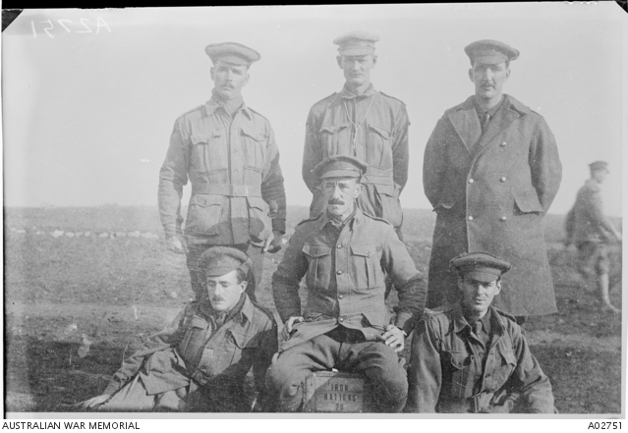
Harold, extreme left, front row with fellow 7 Bn Officers.
He was also Mentioned in Despatched (MID) in 1918 and awarded the Croix de Guerre by the French President. On 19th May 1919, whilst on pre-embarkation leave, he married Regine Marguerite Desfroyenne at Calais.
Harold and his wife returned to Australia aboard the ORVIETO and his appointment with the AIF was terminated.

