250 ALBERT ERNEST MANLEY.

Albert was born at East Stonehouse, Plymouth, Devon, in 1881, the son of John and Catherine Manley.
He joined the AN&MEF on 11th August 1914 and stated that he was a labourer and married. He gave his wife, Eleanor Manley, 23 Marlborough St, Leichardt, as his next of kin. He also stated that he served in the Grenadier Guards (service number 8983, joined 1901).
He had a daughter, Ivy Eileen Louvain Manley, born 1916.
On 18th August 1914, Albert was promoted corporal and to lance sergeant on 1st Feb 1915. He returned to Australia and was discharged on 4th March 1915, time expired, after serving 206 days with the AN&MEF.
On his return he attempted to join the AIF on 8th March 1915 but was found to be medically unfit due to Malaria.
On 6th July 1916 he successfully joined the 15th Reinforcements of the 20th Battalion (service number 5613) and embarked on the EURIPIDES on 9th September 1916 for the UK, arriving at Plymouth on 26th October 1916.
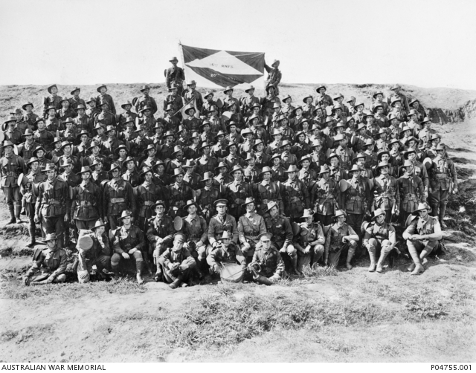
Members of the 15th Reinforcements, 20th Battalion, prior to embarkation on the Euripides 1916
Between his arrival in the UK and 17th December 1916, when he joined his Battalion, he was with the 5th Training Battalion.
Albert was fatally wounded in France on 5th Feb 1917 (fractured skull) dying two days later on the 7th.
Albert is buried at the Dernancourt Communal Cemetery Extension (Plot V, Row A, Grave No.12), and is remembered on Panel 91 at the Australian War Memorial, Canberra.

