308 JOHN LEADBEATER
John was born at Congleton, Cheshire on 18th Jan 1877, the son of Allan Leadbeater and his wife Hannah, nee Kirkland. Hannah died when John was just 7 years old. He joined the Cheshire regiment in 1898 and served in South Africa during the Boer War and then in India, finally being discharged in July 1911 as a colour Sergeant. In Feb 1910 he married Catherine Tavener but the marriage was short lived with Catherine dying in India in August the same year.
On 11th August 1914 he joined C Company AN&MEF stating that he was a carpenter and giving his father at 26 Grove St, Leek, Staffordshire as his next of kin. He was promoted sergeant on 18th August and returned from Rabaul on the MORINDA escourting prisoners. He was discharged on 30th December 1914 having completed 148 days service.
On 12th Jan 1915 he joined the AIF as part of the 5th Reinforcements, 5th Battalion, and was granted a Commission as a @nd Lt on 24th March. He left Melbourne on the HORORAYA on 17th April and joined the 5th Battalion on Gallipoli on 27th July.
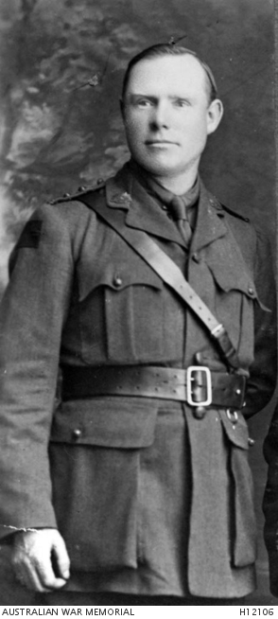

The battalion mover to France and her was promoted Lieutenant on 17th October 1915 and then Captain on 1st April 1916. He was killed at Poziers on 26th July 1916 in the attack on ridge to the right of the village. He was killed by a rifle pr machine gun fire. H e was never buried.
He is remembered at the Australian Memorial at Villes – Bretonneux and on Panel 44 at the Australian War Memorial, Canberra.

