967 SIDNEY CECIL LEER

Sidney was born at Redfern on 9th July 1892, the son of James J Leer and his wife Alice Maud, nee Scaysbrook. On 19th September 1910 he joined the department of Lands as a cadet draughtsman at thee Wagga Wagga Office, In 1914 he was a draftsman working in the Goulburn Office.
On 11th august 1914 he enlisted in D Company AN&MEF stating he was single and giving his father as his next of kin. He was promoted corporal on 9th November and employed in Rabaul as a draftsman. He returned from Rabaul and was discharged on 4th March 1915 after completing 206 days service.
On 20th June 1915 he enlisted in the AIF as part of the 8th Reinforcements, 1st Battalion, regimental number 2607. He sailed from Sydney aboard the RUNIC on 9th August 1915 and after a short period of training in Egypt landed on Gallipoli on 3rd October 1915.
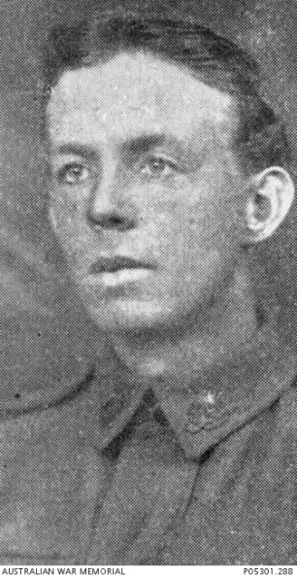

On 4th December 1915 he died of wounds received at Gallipoli and is buried at Shrapnel Valley. He is remembered on Panel 24 at the Australian War Memorial, Canberra.

