569 JOHN REGINALD NUNN

John was born at Redfern on 10th December 1891, the son of Alfred John Nunn and his wife Alice Catherine, nee Morrison. He was a lance corporal in the Australian Coronation Contingent, a group of cadets who went to England for the Coronation of King George V.

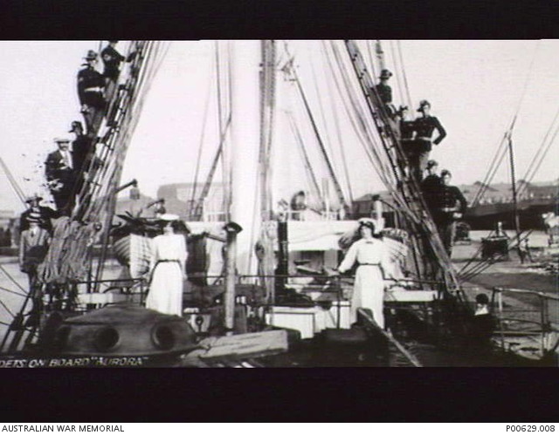
A group of Cadets in England for the Coronation of George V
On returning home he was given a commission as a second lieutenant in the 33rd Infantry Regiment where he was serving when he enlisted in the AN&MEF as a private soldier and was allocated to G Company. He was promoted corporal on 18th August and then sergeant on 20th November. He returned from Rabaul and was discharged on 4th March 1915, having completed 206 days service.
On 7th May he was granted a commission as a lieutenant in the 17th Battalion and left Sydney on 12th May aboard the THEMISTOCLES. He arrived on ANZAC Cove on 20th august and was evacuated on 28th Sept firstly to Malta then to Gibraltar and finally to England. He was supposedly suffering from dysentery, but it was later confirmed he had ulcerated colitis, an incurable auto-immune condition. He returned to his unit on 18th May 1916, but the condition again flared on 18th September when he was again evacuated to England.
He returned to Australia on the KANOWNA departing on 14th Jan 1917. On arrival home he was admitted to the Randwick Military Hospital, where he died on 9th April 1917 aged 26. He is buried at the Waverley General Cemetery and is remembered on Panel 83 at the Australian War memorial, Canberra.

