CAPT THOMAS ROY MCPHERSON

Thomas was born at Kogarah on 25th April 1887, the son of Hunter Kirwin McPherson and his wife Ada Annie Cope, nee Bates. He was educated at Sydney Grammar School and an officer in the NSW Scottish Rifles (CMF). He enlisted in the AN&MEF and assigned D Company as a captain. He stated that he was an electrical engineer and single, giving his father at 493 Kent St Sydney as his next of kin.
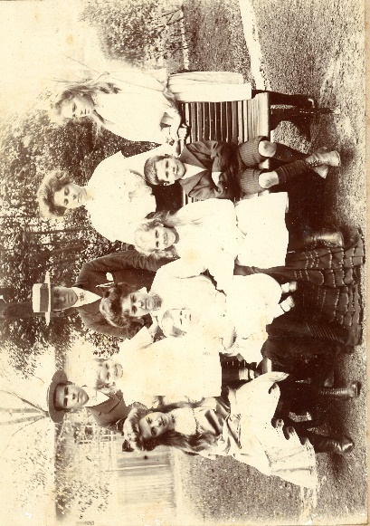
Thomas centre back
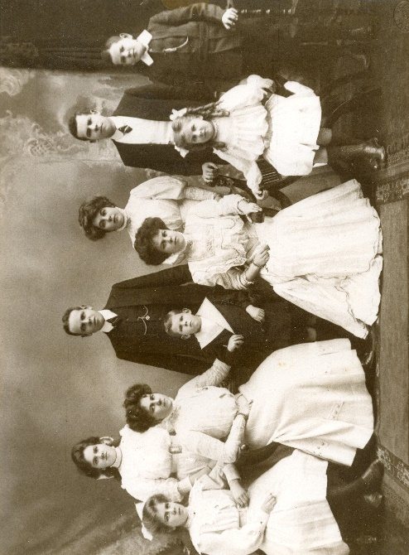
Thomas, 2nd from left, back row.

He returned from Rabaul and on 8th May 1915 was given a commission as captain in the 18th Battalion, AIF. He was promoted Major on 1st June 1915 and embarked on the CERAMIC on 15th June 1915.
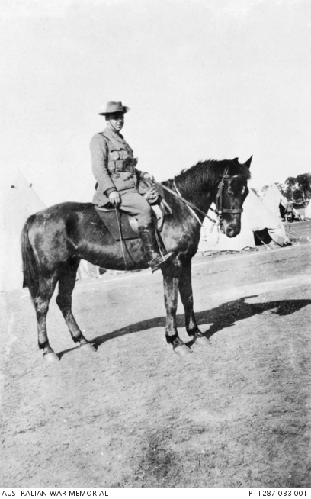
In Egypt early 1915.
He landed on Gallipoli on 16th August and was killed in action just 6 days later on 22nd August 1915.
He is buried at the Lone Pine Memorial and is remembered on Panel 86 at the Australian War memorial Canberra.

