400 REGINALD JOHN CORBETT O’DONNELL

Reginald was born on 24th February 1892 at Paddington, the son of James Patrick O’Donnell and his wife Annie Delisle, nee Evans. He enlisted in the AN&MEF and was allocated to C Company. On enlistment he stated that he was in the Junior Cadets from 1903 till 1905 and the senior Cadets in 1909 and was a bank clerk and single, giving his father at Mangay Station, Coolac as his next of kin.
He returned from Rabaul and was discharged on 4th March 1915 having completed 206 days service.
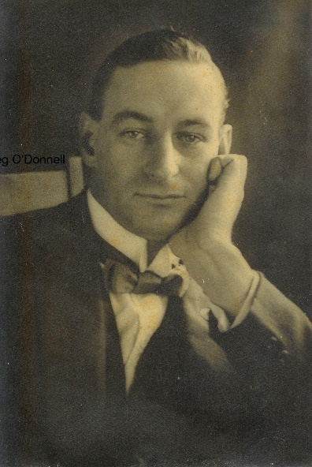
In 1916 he married Lillian Mary Chambers and died in Sydney on 8th August 1966 aged 74. He is buried at the Macquarie Part Cemetery, North Ryde.

