CAPT JAMES LOGIE HARCUS

James was born at Westray, on the Orkney Islands, Scotland on 22nd November 1881, the son of Andrew Harcus and his wife Jean Maria, nee Logie. Andrew died in 1889 and James then lived with his uncle where he became an articled clerk.
At the time of being commissioned as a Captaiin in the AN&MEF, he was a Barrister and a Captain in the CMF, having previously served in the military whilst on the Orkneys. He was assigned to the Machine Gun Section and stated that he was single, giving his mother as his next of kin.
He returned from Rabaul and had his commission with the AN&MEF terminated on 4th march 1915, having completed 206 days service.
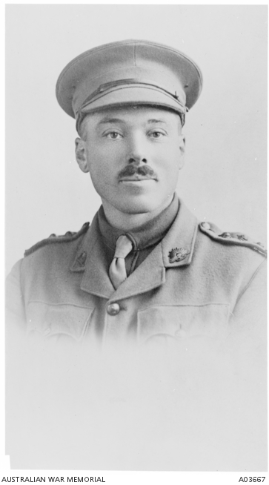

He was given a commission asa Captain in the 20th Battalion on 2nd May 1915 and then promoted Major on 1st June. He left Sydney with the Battalion on 26th June 1915 aboard the BERRIMA, eventually landing on Gallipoli on 16th August. He was killed in action on 11th December 1915 and was buried next day in “..the cemetery at foot of Walker’s Ridge.”
After the war his grave could not be identified so he is remembered on the Lone Pine Memorial. He is also remembered on Panel 91 and the Australian War Memorial, Canberra.

