739 CHARLES EDWARDS MERRETT

Charles was born at Mosman on 15th December 1891, the son of Frederick Henry Ernest Merrett and his wife Emma, nee Parry. He was a plasterer when he enlisted in the AN&MEF and joined his older brother, Frederick Stanley Edward, regimental number 740, in F Company. Like his brother he returned to Australia on the MATUNGAN and was discharged on 18th Jan 1915 having completed 161 days service.
Unlike his brother, Charles enlisted in the AIF on 26th April 1915 and was assigned to the 2nd Reinforcements, 18th Battalion, regimental number 1802. He sailed from Sydney aboard the KANOWNA on 19th June and on 22nd August, at Gallipoli, he received a gunshot wound to the hand (a finger was shot off). He was evacuated to England aboard the Hospital Ship AQUITANIA and then returned to Australia aboard the SEUVIC, arriving back in Sydney on 22nd April 1916.
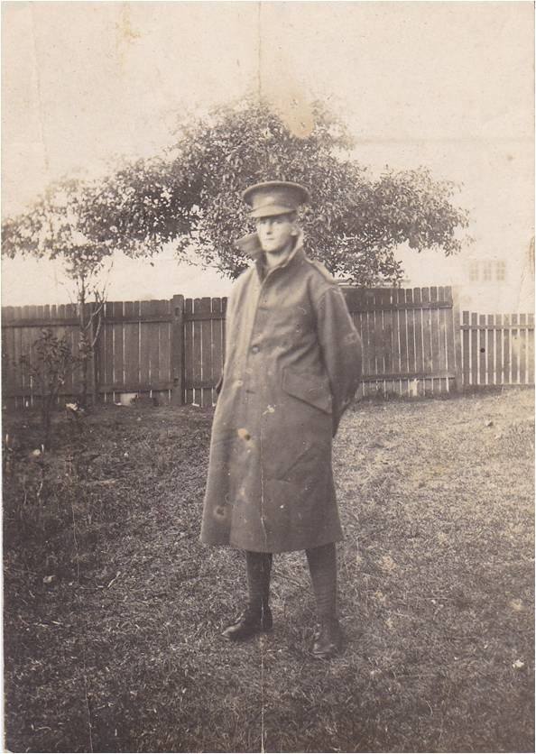

Having recovered sufficiently from his wounds, he returned to the AIF on 6th Feb 1917. He left Sydney on 10th Feb 1917 aboard the OSTERLEY, landing in Plymouth on 12th April. On reuniting with his unit, his regimental number was altered to R1802 (the R symbolising a returning soldier).
On 6th July 1918 Charles was charged with the most unusual crime of “Being in possession of strawberries knowing same to be stolen” for which he was docked 14 days’ pay.
Charles survived the war but was stricken with pneumonia from which he never recovered and died at Rouen, France, on 21st November 1917. He is buried at the St. Sever Cemetery Extension, Rouen and is remembered on Panel 86 (Commemorative) at the Australian War memorial Canberra.

