7 JAMES WILLIAM HODGES MCCULLOUGH

James was born at Redfern on 29th May 1894, the son of William Henry McCullough and his wife Mary Ann, nee Bogdan .On enlistment into the Army Medical Corps, AN&MEF on 12th August 1914, he stated that he was 22 and three months, to avoid having to get his parents consent. He was in fact only 20 years 3 months. He had been a trainee with the AMC prior to enlistment but was an engineer by trade. He returned from Rabaul and was discharged on 4th March 1915 having completed 205 days service.
On 2nd November 10915 he enlisted as a sapper with the 14th Reinforcements, 1st Divisional Signals Company, regimental number 5776. He left Sydney on 21st Jan 1916 aboard the RUNIC, arriving in Alexandria on 27th Feb 1916. He was put to work as a dispatch rider and after relocating to France he was transferred to the 19th Battalion on 12th November 1916. Two days later he was blown off his motorcycle and was evacuated to England on the GLOUCESTER CASTEL and was hospitalised. He remained in England for the rest of the war working in several units mainly in a clerical capacity.
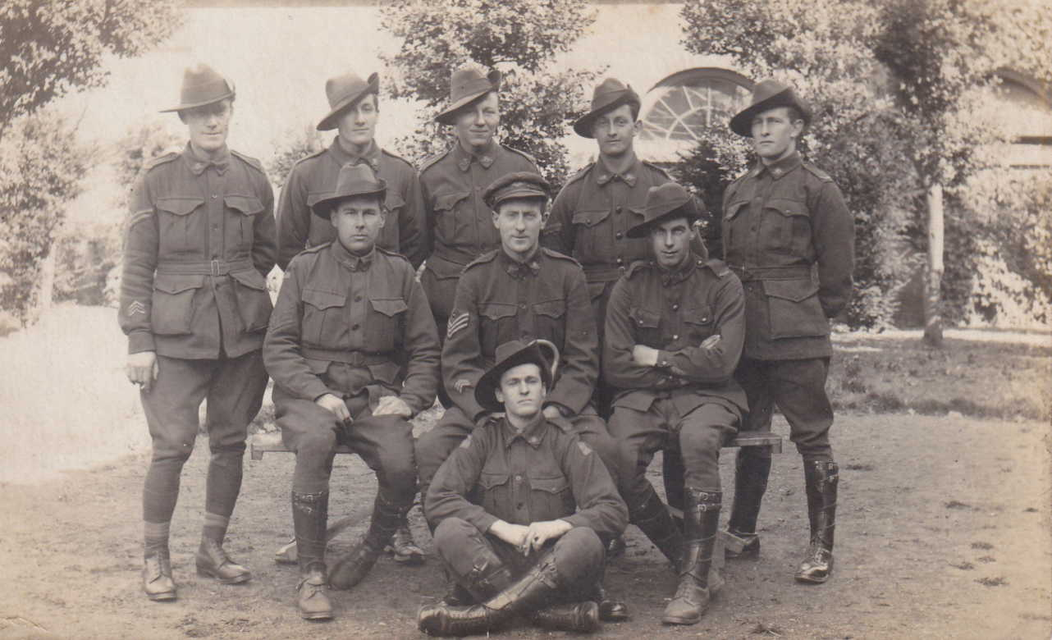
A postcard showing James standing, second on left

On 1st August 1918 he married Lucy May Revell at St Michael’s and All Saints Church, Sheffield and returned to Australia aboard the KONIG LOUISE, leaving England on 18th December 1919 and arriving in Sydney on 7th Feb 1920. He was discharged from the AIF on 10th April 1920 as medically unfit due to –“effects of concussion on brain’.
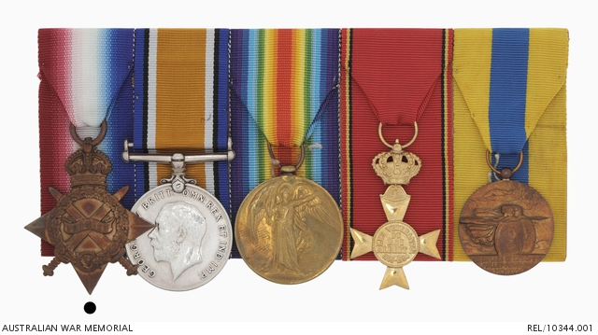
James medals, now in the AWM, Canberra. As well as the three usual medals, there are two unofficial medals, the Les Veterans Du Roi Albert 1 Medal and an the Somme Medal

He returned t o England and lived in Hertfordshire. His wife, Lucy, died in 1953 after which James returned to Australia and moved to Mulgoa, Penrith.
In 1969 he married Hilda Agnes Bogdan, Hilda dying some two years later.
William died at Mulgoa on 13th December 1983 aged 89.

