992 WILLIAM CHARLES HOWARD LAWSON

William was born at Bowral on 28th May 1887, the son of Thompson Arthur Westwood Lawson and his wife Agnes, nee Ginn.
William enlisted in D company, AN&MEF stating that he was a tramway conductor and single and giving his mother at c/- Post Office, Ainslie, Yass – Canberra. Canberra had only been named the year before and no such city excited. The area was then known as the Yass- Queanbeyan region. Ainslie later became one of the City of Canberra first suburbs.
William returned from Rabaul and was discharged on 4th March 1915 having completed 206 days service.
On 11th May 1915 he joined the AIF as a private with the 2nd reinforcements, 17th Battalion, regimental number 1722. Shortly after enlistment he transferred as a driver to the 20th Army Service Corps and was reallocated regimental number 8912.
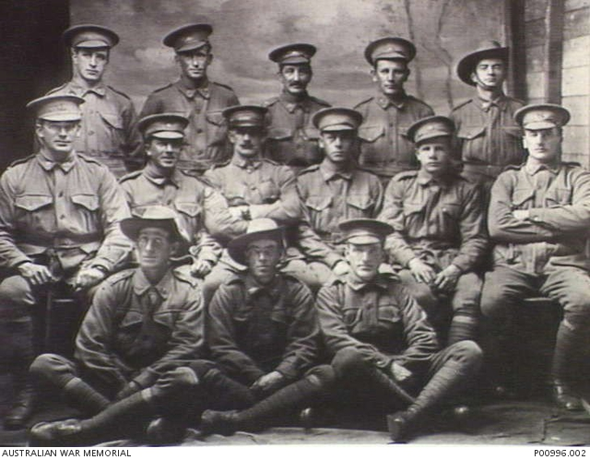
1916 – Second from right, back row.

He sailed from Sydney on 28th July aboard the PERSIC for Alexandria. On 29th March 1916 whilst in France he suffered a bout of Rheumatic Fever and was transferred to the Royal Herbert hospital in England. The fever left him with an enlarged heart and he was returned to Australia on the New Zealand Hospital Ship MARAM arriving back in Sydney on 17th October 1916. He was discharged from the AIF on 4th Jan 1917. He was granted a pension which was subsequently cancelled on 16th Jan 1918, following his restoration to good health.
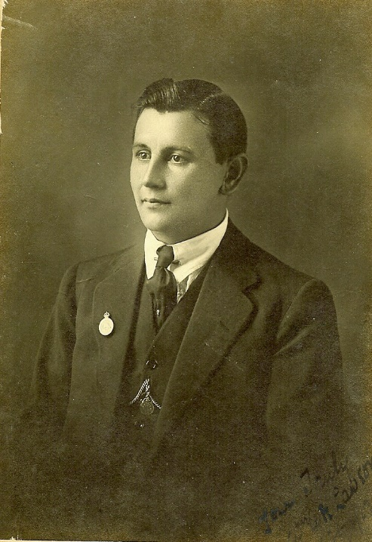
c. 1917

He continued his occupation with the Tramways and in 1920 married Mabel Annie Alice Gale at Parramatta.
William died at Toongabbie on 18th Jan 1978 aged 90/

