MAJ EDWARD FOWELL MARTIN

Edward was born in Launceston, Tasmania, on 22nd August 1875, the son of Edward Martin and his wife Harriett, nee Fowell. On 6th April 1898 he married Lily Mary Davies at Surry Hills. He joined H Company, AN&MEF as a Major, stating that he was an Accountant and giving his wife at 108 Douglas St, Stanmore, as his next of Kin. He returned from Rabaul on the MATUNGAN and was discharged on 4th March 1915 having completed 206 days service.
He was given a Commission in the 17th Battalion as a Major and sailed from Sydney with the battalion on 12th May 1915 aboard the THEMISTOCLES. He arrived on Gallipoli on 20th August and was evacuated back to Alexandria on 13th September suffering from dysentery. And colitis., returning to the peninsular on 8th December.
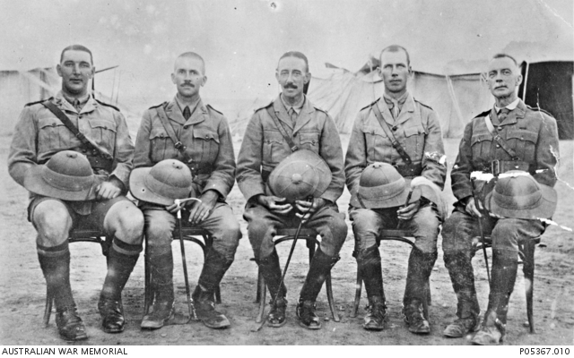
Egypt c1915. Edward second from left with other 17th Bn Officers

Following the withdrawal from Gallipoli he went to Marseilles on 23rd March 1916 and was promoted Lt Col on 19th April. Edward was mentioned in Dispatches (MID) on 6 separate occasions, was awarded the DSO, CMG and CB for his service as well as receiving the Long Service Medal. He was promoted Colonel on 28th June 1918 and was appointed temporary Brigadier on 12th Oct.
He left England aboard the CITY OF EXETER on 12th June 1919, arriving in Sydney on 26th August. His appointment to the AIF was terminated on 8th December 1919.
Edward’s son, Edward Davies Martin also served in the war, regimental number 4874 and returned home only to die some 6 months later, on 26th June 1920 at just 20 years of age. Edward then went and spent time in New Guinea and South Africa before splitting with Lily and moving to Western Australia where, in 1932, he became Sergeant at Arms in the Legislative Assembly a position he held for 12 years.
Lily died in Sydney in 1947 following which Edward married Evelyn Lucy Haslam at Canning.
Edward died at Hollywood Repatriation Hospital on 20th September 1950 aged 75.

