305 ARNOLD KINGSLEY HOSKING

Arnold was born in Wollongong on 14th October 1891, the son of John Charles Hosking and his wife Emily Sarah, nee Badcock. He enlisted in the AN&MEF and was posted to C Company. He stated that he was an engineer and single, giving his mother at ‘Yonga’, Church St, Wollongong as his next of kin. He also stated that he had been in the cadets and senior cadets for 9 years and was currently a second lieutenant in the 37th Infantry (CMF).
He was promoted corporal on 18th August 1914, before the Force departed Sydney, and then appointed lance sergeant on 1st Feb 1915. He returned from Rabaul and was discharged on 4th March 1915 having completed 206 days service.
On 5th May he was commissioned as a lieutenant in the 20th Battalion and sailed with the battalion on the BERRIMA, leaving Sydney on 26th June. With the battalion he landed on Gallipoli on 22nd August. He was promoted captain on 1st March 1916 and was Mentioned in Despatches on 16th August. On 29th December 1916 he was awarded the Military Cross (MC) – “For general good work and devotion to duty. On 8th May during the enemy raid on Bridoux Salient he showed great coolness, and although slightly wounded, remained on duty. He was mentioned in Corps orders for good work during the Brigade operations on the Somme – 26th July to 5th August, and 21st to 27th August 1916.’
On 20th July he was promoted major, and the following photo of the 20th Battalion’s Officers was taken in early September just before he was killed in action. Arnold is in the centre of the front row.
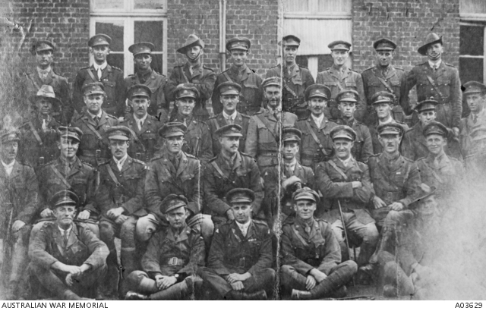
Arnold was killed in action on 20th September and is buried at the Tyne Cot Cemetery, Passchendaele, Belgium.
He left a will in which he stated – “I aint got nothing to leave so I dont give a god damn who gets it.”
He is remembered on Panel 91 at the Australian War Memorial, Canberra.

