868 LEOPOLD WILLIAM MEEK
867 JOHN GEORGE PRIESTLY MEEK
Leopold was born at Palmerston North, NZ on 23rd June 1893 and his brother John at Auckland on 4th July 1894. They were the sons on William Joseph Meek and his wife Martha Ann, nee Nicholson. Both boys served in the Navy, John joining in 1910 and serving in Britain primarily on the HMS PYRAMUS and being discharged in 1914. Leopold became a carpenter before joining in 1912 (#2165) and served mainly in Australia. He badly cut his arm with a circular saw in 1913, before being discharged in May 1914.
They joined the AN&MEF and were allocated to H Company, returning from Rabaul and being discharged on 18th Jan 1915 having completed 161 days service.
John enlisted in the 17th Battalion, AIF on 20th March 1915, regimental number 423, and left Sydney on the THEMISTOCLES on 12th May 1915. After training in Egypt, he landed on Gallipoli on 20th August and was evacuated on 20th Sept 1915 with a gunshot wound to the knee. He was transferred from Mudros to England aboard the GRAMPIAN, before returning to Australia in December aboard the STAR OF ENGLAND. He was discharged from the AIF on 2nd May 1916.
Later the same year he married Beatrice Marjory May Moffatt. He rejoined the AIF on 1st December 1916, regimental number 60367 and was appointed as a sergeant, but was discharged on 20th Feb 1917 when his injured knee caused him further issues.
On 12th April 1940 he enlisted, service number NX12028 and served in Australia until 14th Jan 1943.
He joined the United Nations Relief and Rehabilitation Administration and died in China on 4th April 1947 whilst with that organisation. He was 52 years old.
Like his younger brother, Leopold enlisted in the AIF on 9th Feb 1915 and was allocated to the 4th Reinforcements, 4th Battalion, regimental number 1789. On 17th March 1915 he sailed from Sydney aboard the SHROPSHIRE. Whilst on Gallipoli he suffered a bout of malaria followed by pneumonia, but remined on the Peninsular, being promoted to corporal on 22nd November 1915. After the withdrawal he transferred to the 56th Battalion and was promoted to sergeant whilst the battalion was at Ferry Post.
In June 1916 the unit moved to France and on 20th July he received a gunshot wound to the eye and spent three months in hospital and recuperating. In March 1917 he was charged with altering his paybook and reduced to private. Whilst on leave he married Ethel I‘Anson at the Parish Church, Holbeck, York on 29th August 1917.
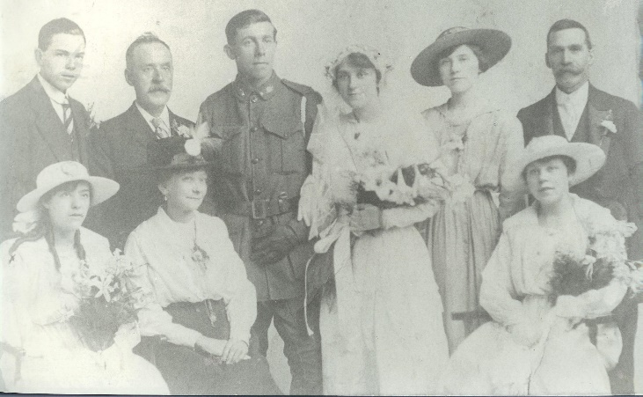
He returned to France and was gassed on 24th April 1918 and evacuated to England, not rejoining his unit until 4th November, just prior to the Armistice.
On 21st June 1919 he and his wife and child, boarded the KONIGN LOUISE, arriving back in Sydney on 16th August 1919.
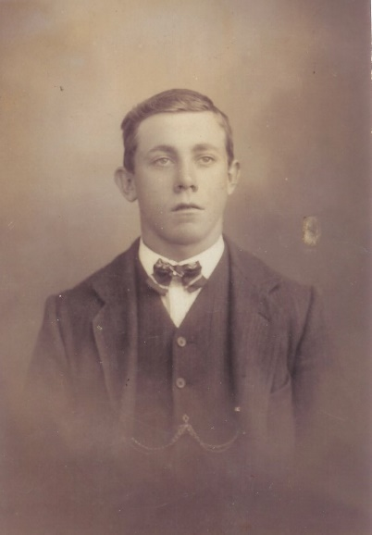

Like his brother, Leopold also enlisted in WW2, serving as a sergeant in the Australian Tank Workshop Company from 25th June 1914 till 29th September 1945, service number NX54260.
Leopold died at Granville on 12th Jan 1964 aged 70.

